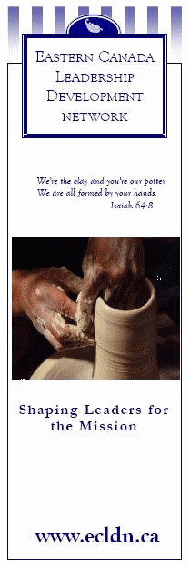

Personal
Ministry
Plan



Leadership Development Network
(Ontario East)

SEPTEMBER 2012

